**COM S 319**

**Construction of User Interfaces**

**Final Proposal for Team 47**

Prepared for

Dr. Abraham Aldaco

Prepared by

Randy Nguyen

[rvnguyen@iastate.edu](mailto:rvnguyen@iastate.edu)

Matthew Duncan

[mlduncan@iastate.edu](mailto:mlduncan@iastate.edu)

April 12th, 2023

**Table of Contents**

Introduction……………………………………………………………………………………….3

Objective………………………………………………………………………………………..4-5

Views……………………………………………………………………………………………5-8

File Format………………………………………………………………………………………...9  
Data…………………………………………………………………………………………...10-11

**Introduction**

Our plan for the final project is to improve upon the midterm project which was a web application that displays the temperature and humidity of a room. We will utilize a Raspberry Pi and a DHT11 to collect the data, and we will use HTML, CSS, and JavaScript to create the web application. We have had a previous interest in Raspberry Pis and we thought this would be a great opportunity to learn more about it while learning what this course is originally about: the construction of user interfaces. Creating a website using the data collected directly by us feels more rewarding than using data from outside sources. And beyond that, learning to work with a platform such as the Raspberry Pi will give us knowledge, we can iterate upon to make more interesting technology in the future. Currently our midterm project is a little basic, so we hope to improve our entire website by “modernizing” the web application by adding things like animations and improved color schemes.

**Objectives**

The following are objectives that we wish to accomplish for this final project:

1. Add more modern features such as animations.

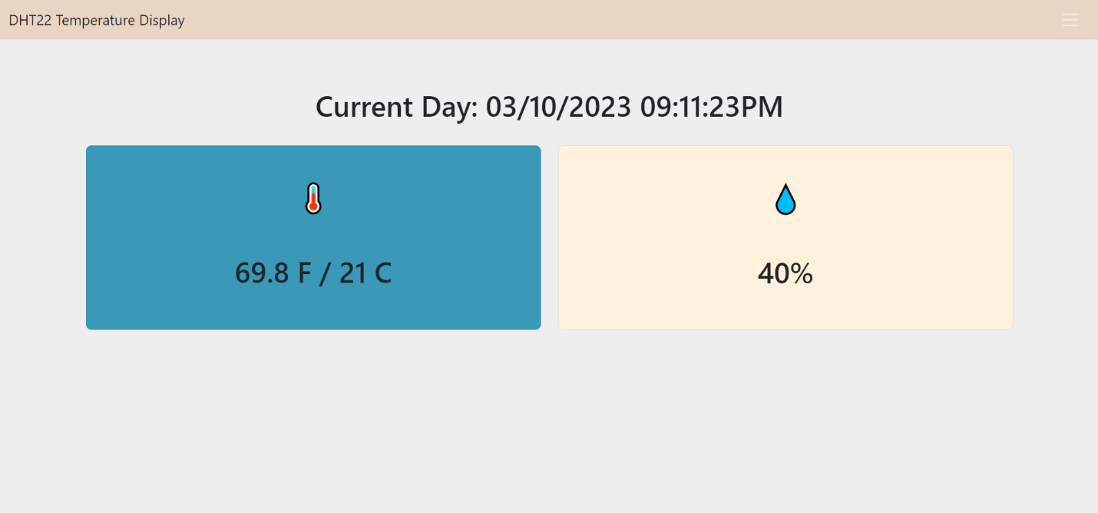

One example is our homepage where users are immediately presented with the information. It may be better to add a proper homepage and add an intuitive transition to the information such as having the user first see a title screen and have an animation when the user scrolls down to view the information.

More animations and transitions can be added throughout the project.

1. Improve the look and color of the web application.

Currently, it’s evident that the color scheme could be improved, and a more visually appealing design would help improve user experience. This could include revamping the two boxes we have for the temperature and humidity to be more interactive and be more visually appealing than just two colored boxes.

1. Add a Gauge

This is a requirement, but we hope to add this with objectives 1 and 2 in mind.

**Views**

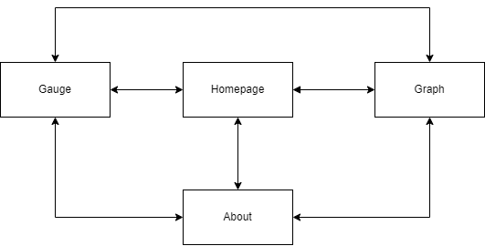

We have a simple web application with only 4 different views. We believe that when trying to obtain information about temperature and humidity complicated views and flows will hinder the user experience. All of these views will be accessible to each other by the navbar.

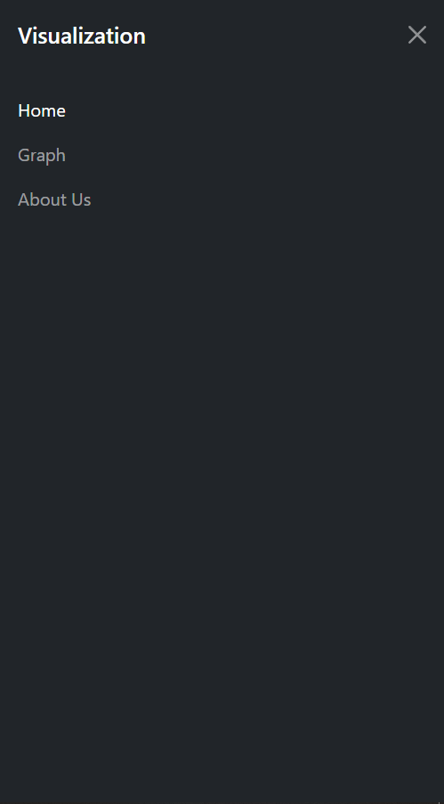

This navbar will be included in each view and we will add a link to the gauge view. The navbar could use improvements visually so we hope to improve it.

**Explanation of Views**

The homepage will greet the user with a title screen and on the same page the user will be able to access the temperature and humidity such as after clicking a button or scrolling down the webpage. As stated before, when trying to obtain temperature and humidity it should be as seamless as possible, so adding it to the homepage will allow the user to quickly access that information, and if they would like to visualize the data in any other way such as a graph or a gauge, they can use the navbar to access those views.

The graph view will be another way for the user to visualize the data. It will be a simple view which just plots the data on a bar graph. We may look into adding selections for more different graphs and ways to manipulate the graph if it makes sense for the data and user experience.

The gauge view will be the final way for the user to visualize the data.

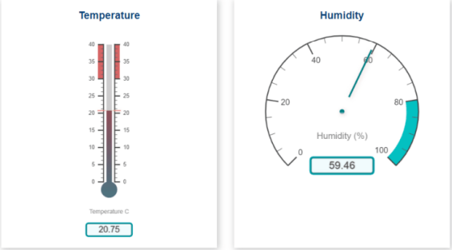

This view will be similar to the examples found from the powerpoint going over the Raspberry pi version of the project Professor Abraham Aldaco provided. It will have images of gauges that will change and update depending on the current temperature and humidity.

**File format**

We plan to have an html file, javascript file, and a css file for each view. These files will allow the functionality and objectives plans we have for each view. We will have a sensor.py file that retrieves the temperature and humidity from raspberry pi and sends that information into a json file called data.json.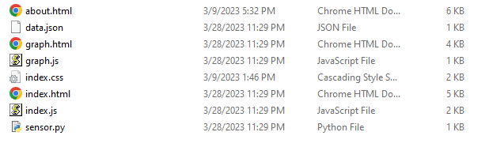

This is what we have so far for our midterm project. The gauge was not implemented during the midterm project. So the necessary files for the gauage will be added to project.

We may separate these files into folders such as placing the html files into an html folder and the raspberry pi related things into a raspberry pi folder.

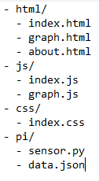

**Data**

The data that our project uses comes from the raspberry pi and script that Professor Abraham Aldaco provided. It collects information about the current temperature and humidity from a sensor connected to the raspberry pi, and outputs that information into a json file.

Currently we collect the data, temperature in Fahrenheit, temperature in Celsius, and the humidity. This information is then used in all visualizations such as the hompage.

The format of the json file was created by us so we can remove or add more information if needed.

So, to summarize the structure, flow and storage of our data. It starts by collecting the information from the raspberry pi and sensor.py will take that information and create a file called data.json that holds that information. That information will be kept within the project directory and each view that needs to use it will access that information.